Quiz Lab Algoritma
Nama : Fathurrohman
NPM : 252310040
Kelas : TI-25-PA
Github :
Hasil Screenshot
Soal 1
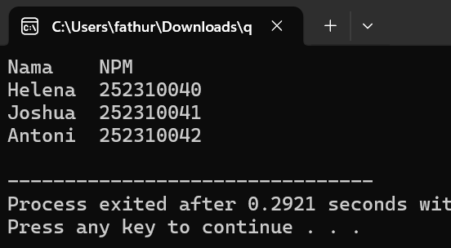

Soal 2
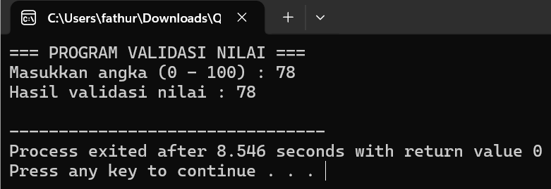

Soal 3
